- Summarize the three reasons why Gregor Mendel chose pea plants to study heredity:

- Mendel only chose to track traits that were true-breeding. What does this mean?

- Define hybridization –

- Using the diagram below, label the P, F₁, and F₂ generations.

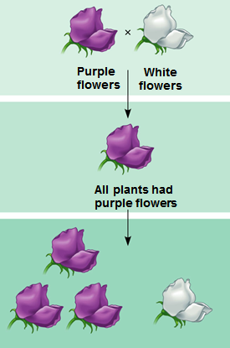

- When Mendel crossed white and purple flowers, what ratios were produced in the

  - F₁ generation?

  - F₂ generation?

- The purple flower color is a ______________ trait, while the white flower color is a

__________________ trait.

- These traits are controlled by ____________, made of _____________, found within

________________.
- Summarize each of the four concepts that make up Mendel’s theory of inheritance:

  - Concept 1 –

Allele –

Locus –

  - Concept 2 –

  - Concept 3 –

  - Concept 4 –

- Write a Punnett square showing the predicted results of a cross between two F₁ generation purple-flowered parents.

- Define homozygous –

- Define heterozygous –

- Define phenotype –

- Define genotype –

- Give the possible genotypes that produce a purple flower phenotype.

- Give the possible genotype that produces a white flower phenotype.

- What question does a testcross answer?

- What two parents are bred in a test cross?

- Write a Punnett square for a dihybrid cross between a homozygous yellow, rounded seed pea plant seed (YYRR) and a homozygous green, wrinkled pea plant seed (yyrr).

- Define the Law of Independent Assortment –

- What kinds of genes does this law apply to?

- Explain the multiplication rule of probability.

- Explain the addition rule of probability.

- Define complete dominance –

- Define codominance –

- Define multiple alleles –

- Why are blood types an example of both codominance and multiple alleles?

- Define incomplete dominance –

- Are dominant traits always the most common ones in a population? Give an example?

- Define pleiotropy –

- Define epistasis –

- Give an example of a qualitative characteristic that cannot be defined numerically.

- Define polygenetic inheritance –

- How are hydrangea flowers an example of a phenotype dependent on environment?

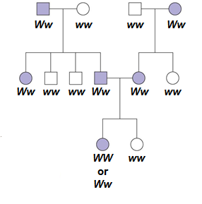
- A human pedigree chart for the Widow’s peak characteristic is shown to the right. Define what each of the following means:

Capital “W” –

Lower case “w” –

Shaded in shapes –

Non-shaded shapes –

Circles –

Squares -

- Describe each of the examples of recessively–inherited disorders.

  - Cystic Fibrosis –

  - Sickle-cell Anemia –

- Why does inbreeding increase the likeliness of recessively-inherited disorders?

